LABORATORY EXPERIMENT: EEE 213

TITLE
Phasor Diagrams

AIM
The aim of this experiment is to demonstrate the validity of using phasors in analysing simple resistive-reactive circuits.

OBJECTIVES
- To measure the phase angle between the input voltage V1 and the capacitor voltage V2 of a series RC circuit by three methods: the oscilloscope method, the digital phase meter (DPM) method and the voltage method.
- To compare the measured phase angles with the value given by phasor theory, θ = tan⁻¹(1/ωCR), for six values of capacitance.
- To draw the phasor diagram for each capacitance from the measured voltages.
- To measure the phase angle of a series RL circuit and find the reactance of the inductor.

APPARATUS
- 2 A Variac (1)
- 100 Ω rheostat (1)
- Switched capacitor (1)
- Inductor (1)
- Digital Phase Meter, DPM 380 (1)
- Oscilloscope, type D54 (1)
Note: The capacitor values are in microfarads (µF). The Variac was set to give an input voltage V1 of 60 V (r.m.s.) at 50 Hz. All connections were checked by a supervisor before power was switched on.

THEORY
When a sinusoidal voltage is applied to a circuit that has resistance and reactance (inductance or capacitance), the current in the circuit is usually not in step with the voltage. The difference in phase between the voltage wave and the current wave depends on the size of the resistance and the reactance. A phasor is a line whose length represents the size of a voltage or current and whose direction represents its phase. Circuits that are combinations of R, L and C can be studied by adding the phasors of each element.
For an ideal resistor, the current is in phase with the voltage, and V = I R. For an ideal inductor, the current lags the voltage by 90°, and V = jωL I. For an ideal capacitor, the current leads the voltage by 90°, and V = I / (jωC). The opposition of an inductor to current is its reactance Xₗ = 2πfL ohms, and that of a capacitor is Xᶜ = 1 / (2πfC) ohms, where f is the frequency in hertz, L is the inductance in henries and C is the capacitance in farads.
In the series RC circuit, the same current I flows in R and C. The resistor voltage VR is in phase with I, and the capacitor voltage VC = V2 lags I by 90°. The input voltage V1 is the phasor sum of VR and VC. Let θ be the phase angle of the RC circuit (the angle between I and V1), and let φ be the angle between V1 and V2, which is what is seen on the oscilloscope. From the phasor diagram:
φ = 90° − θ θ = tan⁻¹ (VC / VR) = tan⁻¹ (1 / ωCR) θ = sin⁻¹ (V2 / V1)
So, if φ is measured, θ is found from θ = 90° − φ. This value of θ can then be checked against the values from the voltage method and from the theory. The three methods of measuring φ are:
- Oscilloscope method: measure the time interval between the two waves. The period of a 50 Hz wave is 20 ms, so φ = (time interval in ms / 20 ms) × 360°.
- DPM method: read the phase angle directly on the digital phase meter.
- Voltage method: measure the amplitudes of V1 and V2 on the oscilloscope and calculate θ = sin⁻¹ (V2 / V1).
In the RL circuit, the voltage across the inductor VL leads the current by 90°, while VR = V2 is in phase with the current. So V1 leads V2 by the angle φ = tan⁻¹ (VL / VR) = tan⁻¹ (Xₗ / R). The reactance of the inductor can therefore be found from Xₗ = R tan φ. Although this experiment uses only R and C (and then R and L), the same principles can be used for R-L-C circuits.

DIAGRAM
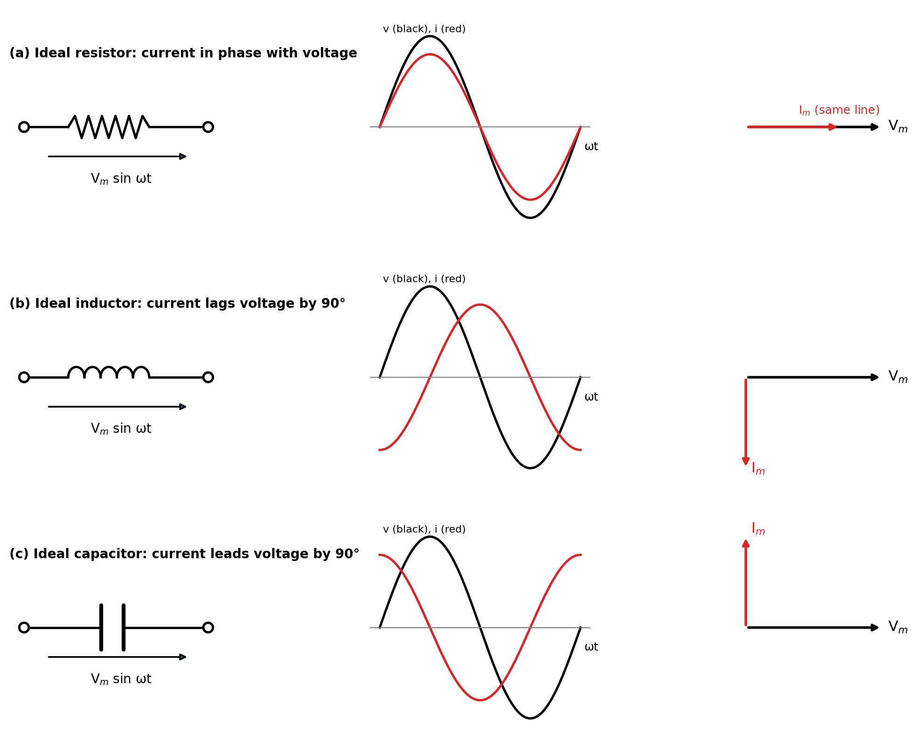
Figure 1: Voltage, current and phasors for an ideal resistor, inductor and capacitor
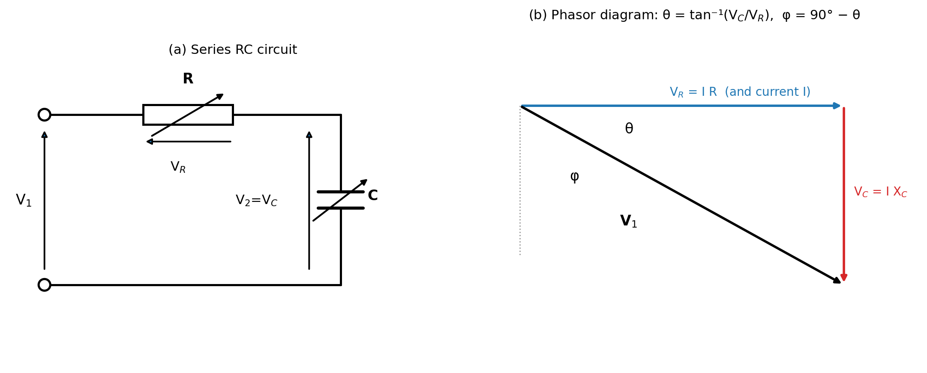
Figure 2: Series RC circuit and its phasor diagram
(a) RC circuit connected to the Variac, DPM and oscilloscope (Task A)
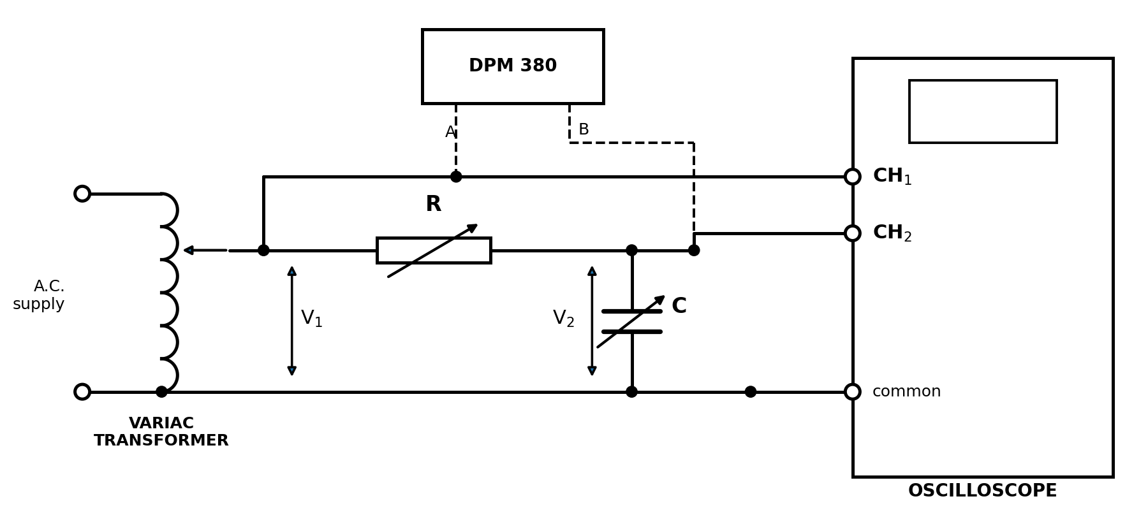
Figure 3: Connection of the RC circuit
(b) RL circuit (Task B)
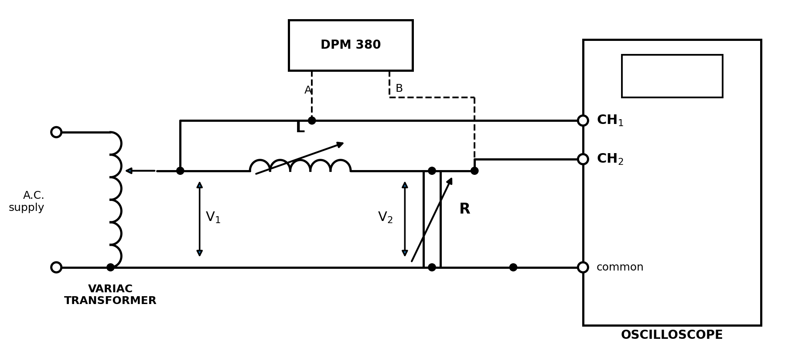
Figure 4: Connection of the RL circuit
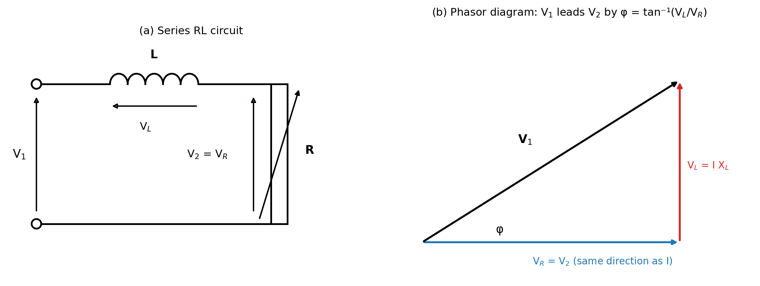
Figure 5: Series RL circuit and its phasor diagram

PROCEDURE
Connect up the circuit as shown in Figure 3. Make the following settings:
A. Oscilloscope
- Set the vertical scale (VOLTS/CM) controls of channels 1 and 2 to 50 V/cm.
- Set the VARIABLE vertical controls (red knobs) of channels 1 and 2 to CAL.
- Switch both channels ON.
- Switch both channels to A.C.
- Set the CHOP/ALT control to CHOP.
- Press the channel 1 TRIG control in.
- TRIG SELECTOR: only the bottom button pressed in, for INT.
- Set the switched time base (TIME/CM) to 5 ms/cm.
- Set the VARIABLE time base control (red knob) to CAL.
- Set the TRIG LEVEL control (red knob) to AUTO.
- Set the STABILITY control to mid-position.
- Set the POSITION control (red knob) to mid-position.
- Set the GAIN control to CAL.
B. DPM 380 (starting from the left-hand side)
- Sync channel switch up, to “Channel A”.
- Channel B switch up (not to “+180°”).
- Frequency (Hz) setting to “10 – 100”.
- Display time control set to 10 from the fully anticlockwise position.
- Selector switch to the “multi-period” position on the left-hand side.
- Store/follow switch to “follow”.
C. Switched capacitor and rheostat
- Set the capacitor to 60 µF.
- Set the rheostat to 100 Ω.
Switch the power on to the Variac, DPM and oscilloscope. Adjust the Variac dial to 60 and adjust the oscilloscope picture to show two clear sine waves. If this is not possible, check all the settings again and call a member of the laboratory staff.
Task A: RC circuit
- Observe the two 50 Hz sinusoidal voltages V1 and V2 on the oscilloscope. The phase angle between them depends on the values of R and C. Check this by varying R and C and watching the changes on the screen. Then return R and C to 100 Ω and 60 µF.
- Method (i), oscilloscope: switch the inputs of channels 1 and 2 to ground (GND). Two horizontal lines appear. Use the vertical position controls to place both lines on the main horizontal line. Switch both channels back to A.C. so the two waves are symmetrical about this line.
- Change to a faster TIME/CM setting and a greater VOLTS/CM setting until the phase gap between the waves almost fills the screen. Measure the interval between the waves in cm, noting that V1 leads V2.
- Calculate: time interval = cm interval × time base setting, and then phase angle φ = (time interval in ms / 20 ms) × 360°.
- Method (ii), DPM: read the phase angle φ directly on the DPM.
- Repeat methods (i) and (ii) for C = 50, 40, 30, 20 and 10 µF. Complete method (i) for all the capacitors first, because it needs different oscilloscope settings from method (iii). This fills columns 1, 2 and 4 of the table.
- Method (iii), voltage: measure the amplitudes of V1 and V2 on the oscilloscope for each capacitor value and calculate θ = sin⁻¹ (V2 / V1).
- After the experiment, calculate θ = tan⁻¹ (1 / ωCR) for each value of C and compare it with the measured values.
Task B: RL circuit
- Disconnect the first circuit and reconnect it with an inductor, as shown in Figure 4.
- Measure and record the phase difference between V1 and V2 by all three methods. Note that V1 leads V2 because the circuit is inductive.

OBSERVATION
Frequency f = 50 Hz (ω = 314.2 rad/s), R = 100 Ω, input voltage V1 = 60 V r.m.s. (amplitude 85 V). Here φ is the angle between V1 and V2, and θ* = 90° − φ.
Table 1: Phase angle of the RC circuit (Task A)
(i) Oscilloscope method |  |  | (ii) DPM method |  | (iii) Voltage method |  |  | R (Ω) | C (µF) | θ = tan⁻¹ (1/ωCR) (°)
Time interval (ms) | φ (°) | θ* = 90−φ (°) | φ (°) | θ* = 90−φ (°) | V1 (V) | V2 (V) | θ* = sin⁻¹ (V2/V1) (°) | R (Ω) | C (µF) | θ = tan⁻¹ (1/ωCR) (°)
3.40 | 61.2 | 28.8 | 62.0 | 28.0 | 85 | 40.0 | 28.1 | 100 | 60 | 27.9
3.20 | 57.6 | 32.4 | 57.4 | 32.6 | 85 | 45.5 | 32.4 | 100 | 50 | 32.5
2.90 | 52.2 | 37.8 | 51.6 | 38.4 | 85 | 53.0 | 38.6 | 100 | 40 | 38.5
2.40 | 43.2 | 46.8 | 43.4 | 46.6 | 85 | 62.0 | 46.8 | 100 | 30 | 46.7
1.80 | 32.4 | 57.6 | 32.0 | 58.0 | 85 | 71.5 | 57.3 | 100 | 20 | 57.9
1.00 | 18.0 | 72.0 | 17.5 | 72.5 | 85 | 81.0 | 72.4 | 100 | 10 | 72.6
The phase angle θ from the three methods is close to the theoretical value for every capacitor. As C becomes smaller, the reactance of the capacitor becomes larger, so V2 becomes larger and the angle θ becomes larger.
Sample calculation (C = 60 µF)
Oscilloscope method: time interval = 3.4 cm × 1 ms/cm = 3.4 ms. φ = (3.4 / 20) × 360° = 61.2°. θ* = 90° − 61.2° = 28.8°.
DPM method: φ = 62.0°, so θ* = 90° − 62.0° = 28.0°.
Voltage method: θ* = sin⁻¹ (V2 / V1) = sin⁻¹ (40.0 / 85) = 28.1°.
Theory: Xᶜ = 1 / (2π × 50 × 60 × 10⁻⁶) = 53.1 Ω. θ = tan⁻¹ (53.1 / 100) = tan⁻¹ (0.531) = 27.9°.
Table 2: Phasor lengths from the measured voltages (V1 = 60 V r.m.s.)
C (µF) | Xᶜ (Ω) | V1 (V) | VR (V) | VC = V2 (V) | VR length (cm) | VC length (cm)
60 | 53.1 | 60 | 52.9 | 28.2 | 5.29 | 2.82
50 | 63.7 | 60 | 50.7 | 32.1 | 5.07 | 3.21
40 | 79.6 | 60 | 46.9 | 37.4 | 4.69 | 3.74
30 | 106.1 | 60 | 41.0 | 43.8 | 4.10 | 4.38
20 | 159.2 | 60 | 32.4 | 50.5 | 3.24 | 5.05
10 | 318.3 | 60 | 18.2 | 57.2 | 1.82 | 5.72
VC (r.m.s.) = 60 × (V2 / V1), and VR = √(V1² − VC²). Lengths are for a scale of 1 cm = 10 V. Example (C = 60 µF): VC = 60 × 40.0 / 85 = 28.2 V; VR = √(60² − 28.2²) = 52.9 V.
Task B: RL circuit (R = 100 Ω)
Table 3: Phase angle φ between V1 and V2, RL circuit
R (Ω) | Time interval (ms) | φ scope (°) | φ DPM (°) | V1 (V) | V2 (V) | φ = cos⁻¹ (V2/V1) (°) | φ = tan⁻¹ (Xₗ/R) (°)
100 | 1.80 | 32.4 | 32.0 | 85 | 72 | 32.1 | 32.1
Sample calculation: φ (scope) = (1.80 / 20) × 360° = 32.4°. From the voltages: φ = cos⁻¹ (72 / 85) = 32.1°. The voltage across the inductor is VL = √(85² − 72²) = 45.2 V (amplitude). Reactance of the inductor: Xₗ = R × VL / VR = 100 × 45.2 / 72 = 62.7 Ω, so L = Xₗ / (2πf) = 62.7 / 314.2 = 0.200 H. The inductor is taken to be about 0.2 H, which gives the theoretical Xₗ = 2π × 50 × 0.2 = 62.8 Ω and φ = tan⁻¹ (62.8 / 100) = 32.1°.

GRAPH
Graph 1 shows the oscilloscope picture for C = 60 µF. The time interval between the two waves is about 3.4 ms, which is a phase difference of about 62° with V1 leading V2.
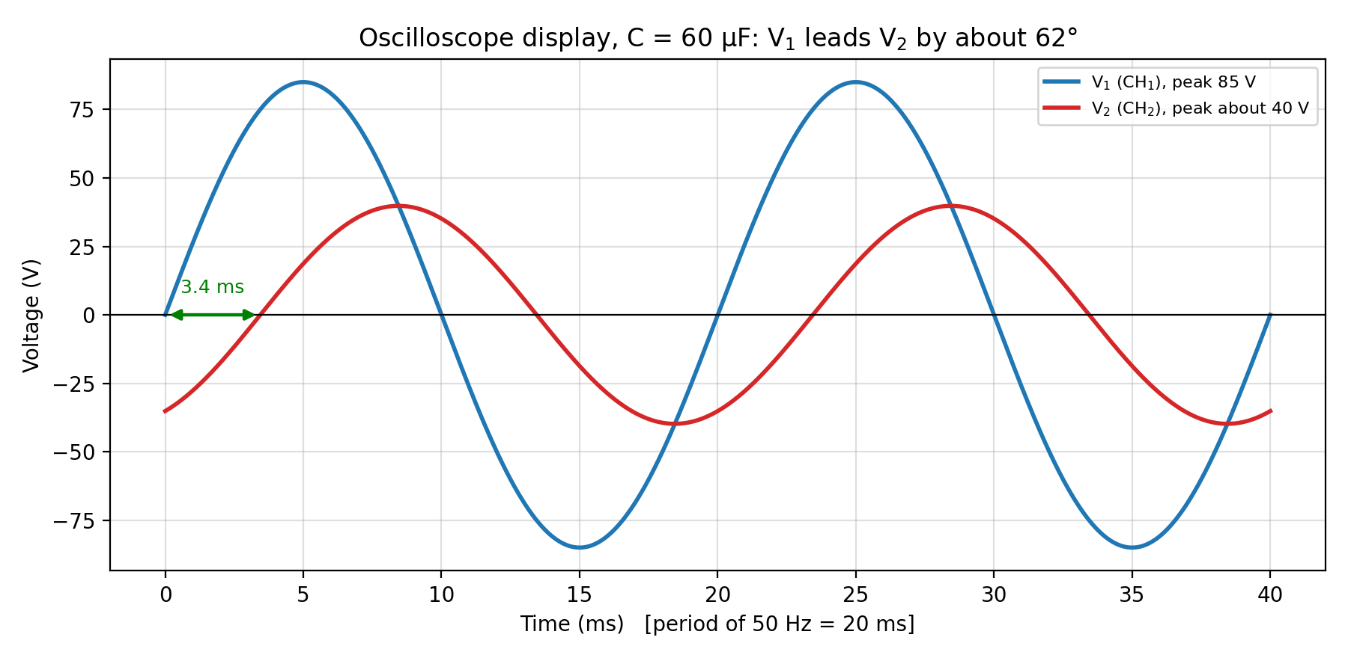
Graph 1: V1 and V2 as seen on the oscilloscope (C = 60 µF)
Graph 2 shows the phase angle θ against capacitance. The curve is the theoretical value and the points are the measured values from the three methods. The points lie very close to the curve.
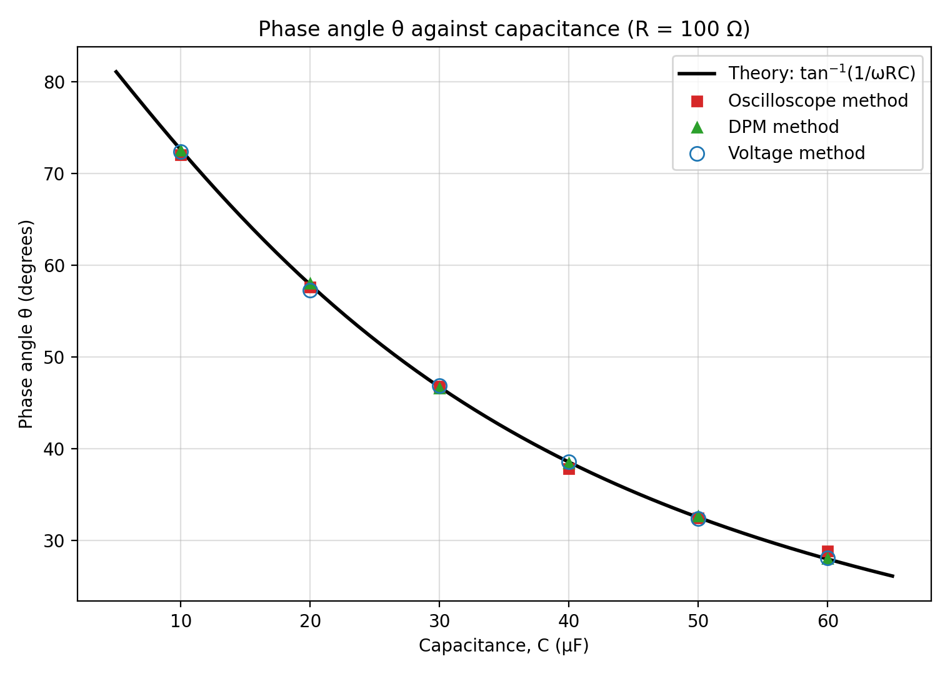
Graph 2: Phase angle θ against capacitance C
Graph 3 shows the phasor diagrams for the six capacitor values superimposed on one another, drawn from Table 2. The current phasor and all the VR phasors lie along the same line (they are colinear). Each V1 phasor has the same length (6.0 cm = 60 V), and the lengths of VR and VC change with C.
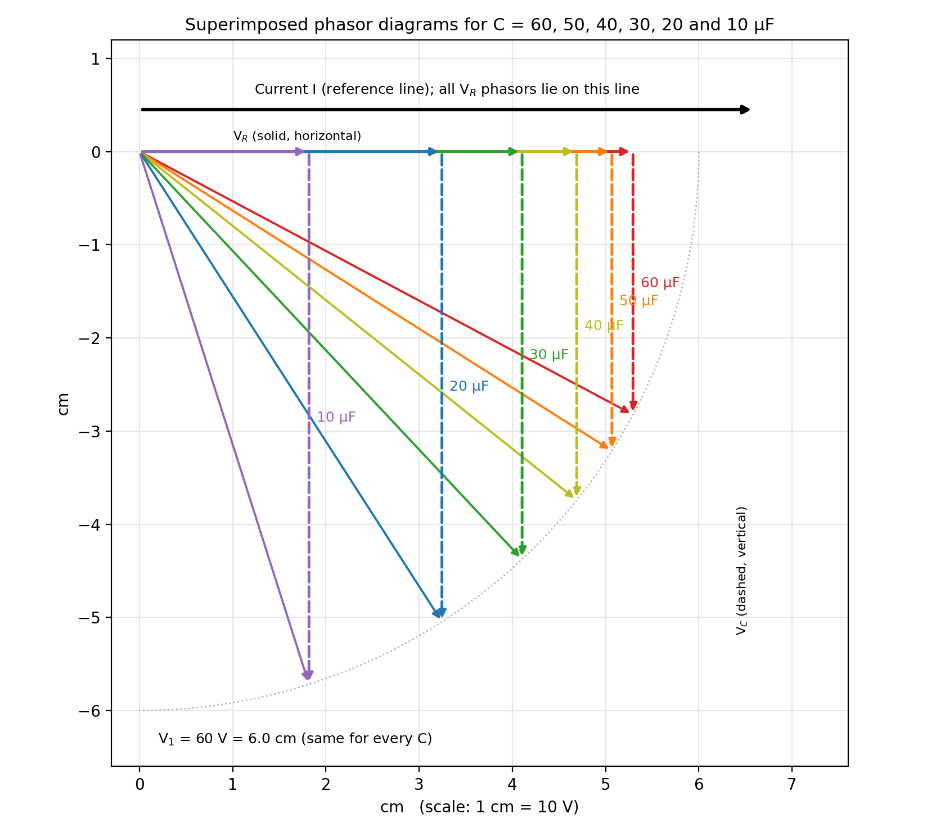
Graph 3: Superimposed phasor diagrams of the RC circuit (1 cm = 10 V)
Graph 4 shows the phasor diagram for the RL circuit (Task B). V1 is the sum of VR and VL, and V1 leads VR = V2 by about 32°.
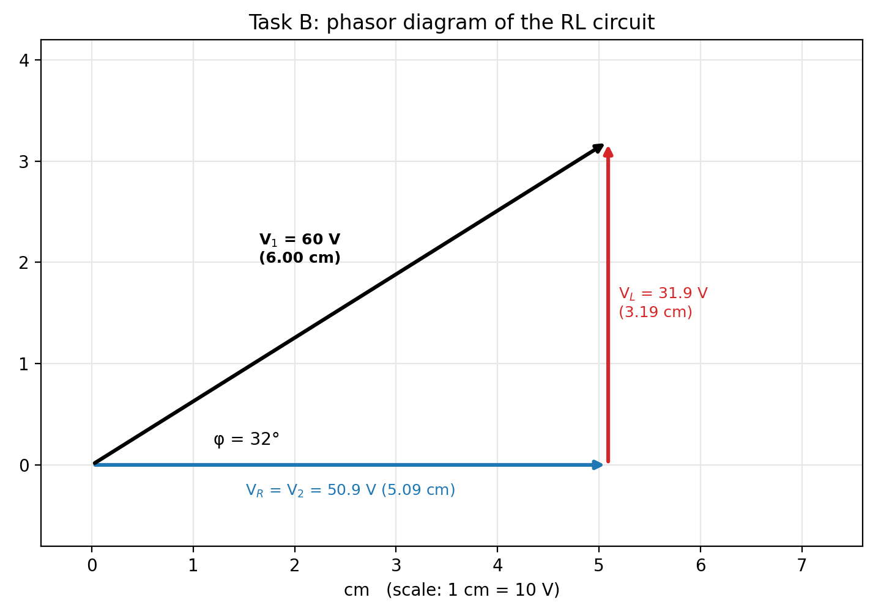
Graph 4: Phasor diagram of the RL circuit (Task B)

PRECAUTIONS
- All connections were checked by a supervisor before the power supply was switched on.
- The Variac was set to zero before switching on and was increased slowly to 60.
- The oscilloscope controls were set to CAL, and both channels were grounded and centred before the time interval was measured.
- The time base and volts/cm settings were expanded so that the phase gap almost filled the screen, to reduce reading error.
- Method (i) was completed for all the capacitors before method (iii), because the two methods need different oscilloscope settings.
- The readings were taken with the eye directly in front of the screen to avoid parallax error.
- The rheostat current was kept below its rating, and all equipment was switched off after the experiment.

CONCLUSION
(i) Comparison of the values of θ. The values of θ from the oscilloscope method, the DPM method and the voltage method agree closely with each other and with the theoretical values from tan⁻¹ (1/ωCR). The oscilloscope values differ from theory by less than 1°, the voltage method by less than 0.6°, and the DPM by less than 0.2°. The DPM is the most accurate because it gives a digital reading. The oscilloscope method is limited by the thickness of the trace and the difficulty of reading the exact crossing point. The voltage method depends on reading two amplitudes, and its error is larger when V2 is small compared with V1. The theory uses the marked values of R and C, which are only accurate to their tolerances (for example ±5 % or ±10 %), and this also causes small differences.
(ii) Phasor diagrams. Graph 3 shows the phasor diagrams for all six capacitor values drawn on one another, with the current phasor and VR along one line and VC at 90° to it. The V1 phasor is 6.0 cm (60 V) in every case. For C = 60 µF, VR = 5.29 cm and VC = 2.82 cm; for C = 10 µF, VR = 1.82 cm and VC = 5.72 cm (see Table 2). The diagrams close properly, which shows that V1 is the phasor sum of VR and VC, that is, V1² = VR² + VC².
(iii) Reactance of the inductor in Task B. The reactance is Xₗ = R tan φ = 100 × tan 32.1° ≈ 62.7 Ω (about 63 Ω), which gives an inductance of about 0.200 H at 50 Hz.
Overall, the experiment showed that phasor theory correctly predicts the phase angles in simple resistive-reactive circuits. The current leads the voltage in the capacitive circuit, and V1 leads V2 in both the RC and RL circuits.

